6.56:
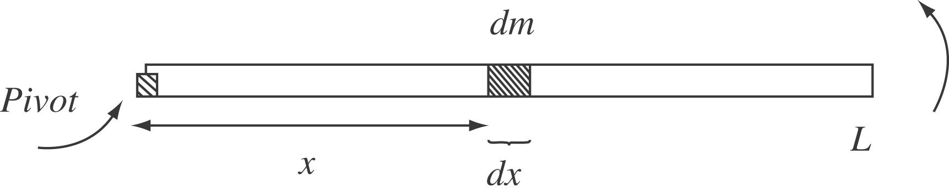

Let 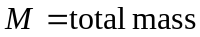 and 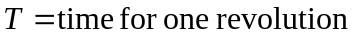

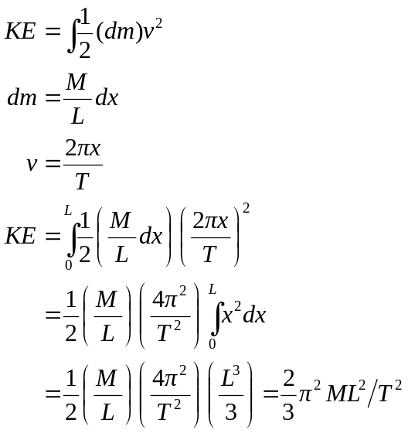

5 revolutions in 3 seconds 